Embalming Sciences Instructor
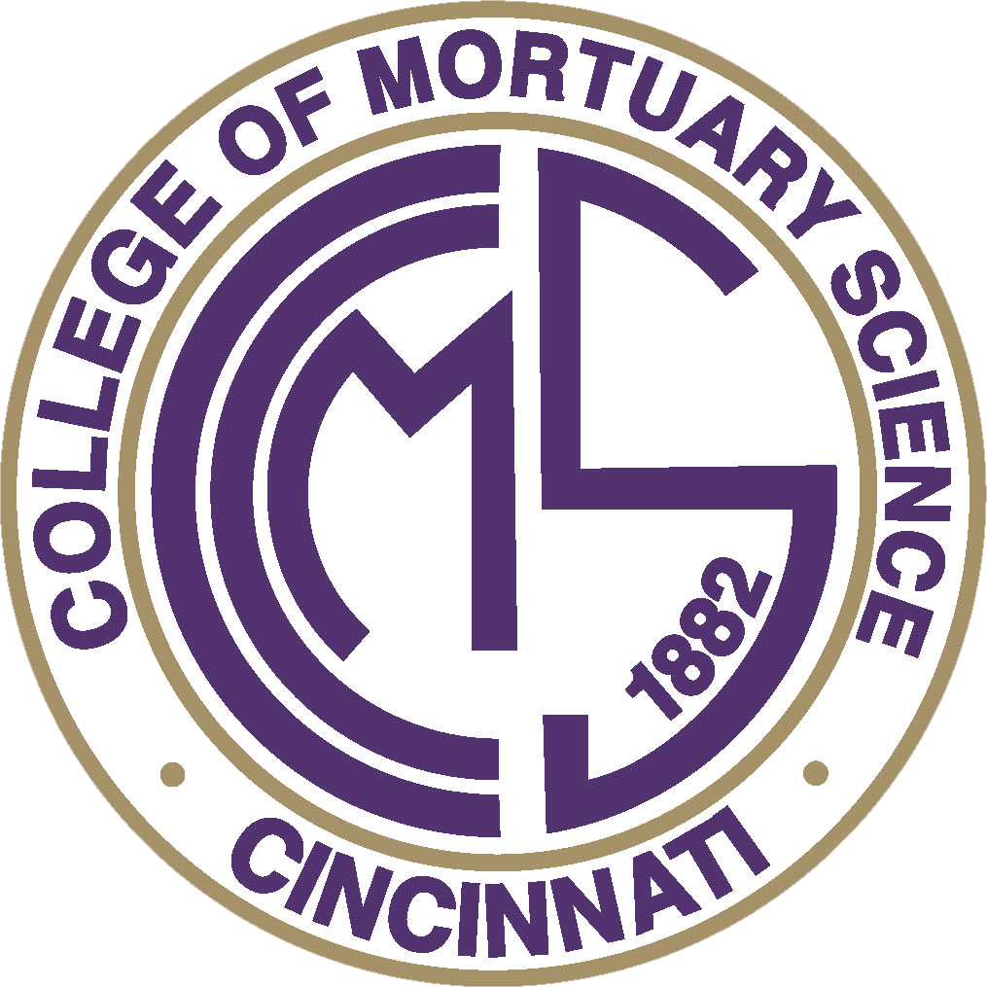

Position Description

This position serves to teach the embalming science courses to students, and to ensure the continuity and integrity of student and alumni academic records of a small, private, not profit, regionally and professionally accredited higher education institution. The instructor works directly with all constituents including faculty, staff, students, alumni, as well as federal and state agencies and accreditors to ensure compliance with accreditation standards and Department of Education standards. The best fit candidate is organized, attentive to detail, articulate, outgoing, has a positive and attentive disposition, and presents him/her/them self in a professional, warm, always inviting manner.

Employer Expectations Overview
CCMS is a community of integrity and excellence comprised of student-focused death care educators and administrators. Our campus culture embraces the expectation that each member of its community govern with conviction in the betterment and service of others. Our team values the institutional mission and the responsibilities entrusted to us, both collectively and individually, to promote expansive knowledge, professionalism, ethical guidance, positivity and support of others.

Essential Skills and Attributes
A successful candidate and team member brings the following minimum skills and attributes:
- Desire to serve in higher education that is specialized in death care
- Support the needs of a diverse community of students, colleagues, and professionals
- Exercises confidentiality at all times and acts in compliance with federal, state, institutional standards
- Governs oneself with autonomy, integrity, and reverence for others
- Holds others accountable for the same standard of integrity and reverence
- Ability to observe, analyze, assess, and develop concepts/plans for improvement
- Possesses a pleasant, approachable disposition and a genuine willingness to help others
- Displays intentional regard and kindness, ensuring a positive experience for all with each encounter
- Displays effective and professional communication skills verbally, non-verbally, and electronically
- Desires to receive instruction, experience professional growth, and act collaboratively as a team
- Possess excellent organizational skills and the ability to prioritize, multitask, and meet deadlines
- Willingness to learn new technologies, programs, and processes associated with position
- Punctuality and history of excellent attendance and is flexible with scheduling
- Ability to read, translate data, and type fluently with accuracy
- Lifting (up to 50lbs), balancing, pushing/pulling, climbing, and kneeling

Essential Job Functions
- Develops and delivers course materials in a clinical setting in accordance with ABFSE curriculum guidelines.
- Teach and demonstrate assigned courses in an approach that enhances student learning.
- Maintain the academic integrity and advancement of the assigned discipline.
- Collaborate other faculty instructors, as needed, to determine resources and needs of academic programs.
- Prepare and distribute course syllabi, materials and study aids.
- Schedule and maintain adequate office hours.
- Appropriately assess student learning outcomes for assigned subjects; develop, administer, and grade quizzes, exams and projects.
- Regularly update course presentations, materials, and resources to meet the learning needs of students and the academic program.
- Ensure ABFSE course curricula, requirements, course outlines and materials are taught in assigned courses.
- Submit grades and required assessments in a timely manner; provide student progress and feedback to students in a timely manner.
- Participate in, and help prepare College events, recruitment activities, etc.
- Maintain highest levels of personal integrity and ethical behavior in all duties and situations.
- Completes other duties as assigned.

Qualifications
- Master’s degree and equivalent job-related experience required. Bachelor’s degree with completion of master’s degree within 5 years to teach ABFSE courses will be considered.
- Min. 7 yrs. Experience as an Ohio licensed funeral director and embalmer required.
- Must be a citizen of and/or authorized to work in the United States

Reports to
- Dean of the College and President & CEO

Employment Classifications and FLSA Status
- Administrative Position
- Salaried/Exempt
- Full-time / On-Site (40 hours per week, Monday-Friday, On-call coverage, evening/weekends)
- Eligible for annual merit bonus

This is a general explanation of the nature and level of responsibilities, skill sets, functions, and qualifications necessary to be a successful fit in this position. It is not intended to be all inclusive or be interpreted as an employment contract. Requirements and essential functions are subject to change.

CCMS is an equal opportunity institution and employer. All aspects of employment including the decision to hire, promote, discipline, or discharge, will be based on merit, competence, performance, and business needs. We do not discriminate on the basis of race, color, religion, marital status, age, national origin, ancestry, physical or mental disability, medical condition, pregnancy, genetic information, gender, sexual orientation, gender identity or expression, veteran status, or any other status protected under federal, state, or local law. Reasonable accommodations may be made to enable individuals with disabilities to perform the skills required for the essential functions of the job.

Cincinnati College of Mortuary Science
645 W North Bend Rd.
Cincinnati, Ohio 45224
Phone: (513) 761-2020 Email: info@ccms.edu Web: www.ccms.edu

